
Touchstones Project
Netcards

Grief Netcards with Text

Avoiding Grief HRJ
Candle HRJ
Clock HRJ
Crying HRJ

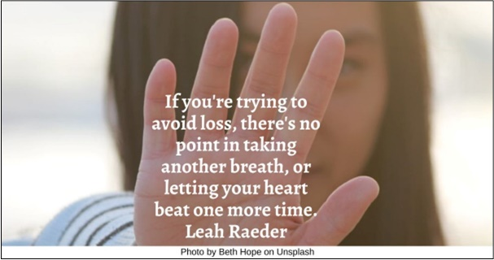



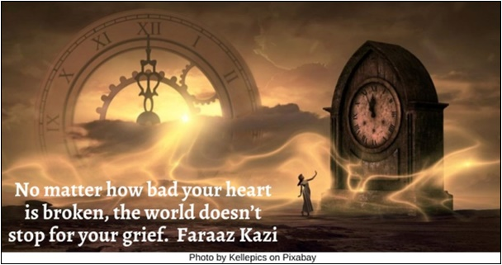

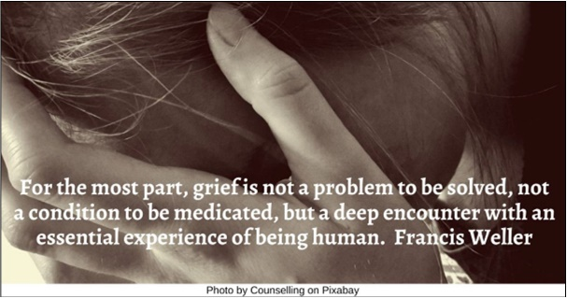

DNA Strand HRJ
Fertile Ground HRJ
Flowers in Vase HRJ
Forest HRJ

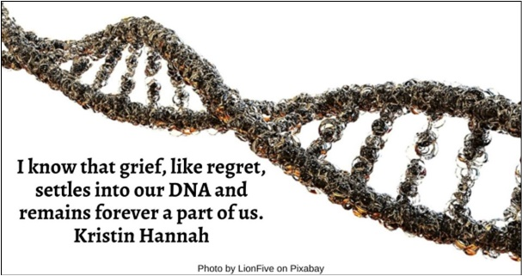







Gravestone HRJ
Grief HRJ
Heart HRJ
Hourglass broken HRJ







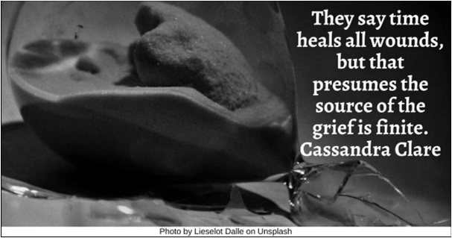

Invitation HRJ
Kindness HRJ
Maze HRJ
Medicine HRJ

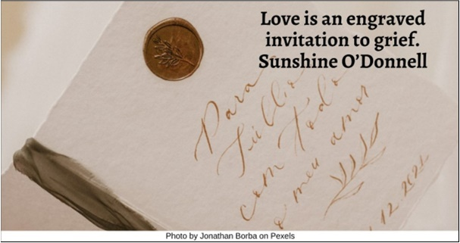



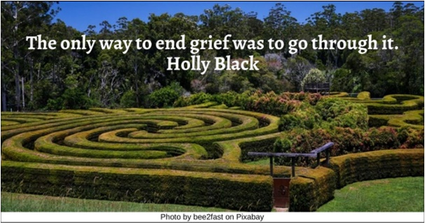



Music HRJ
Ocean HRJ
Old Woman HRJ
Photographer HRJ

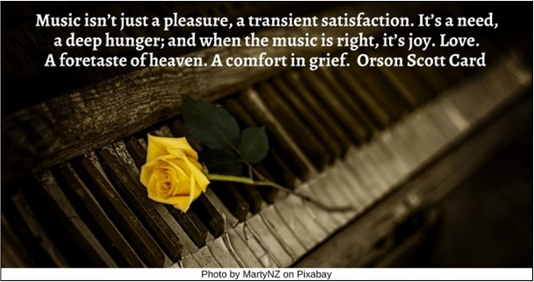

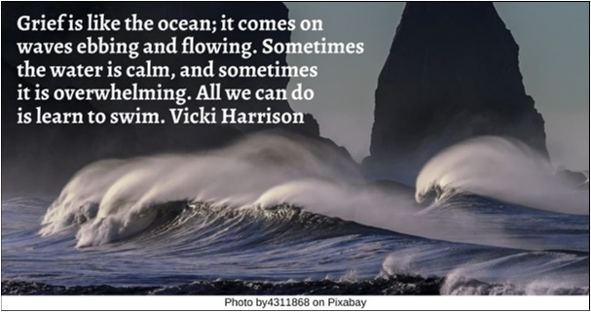

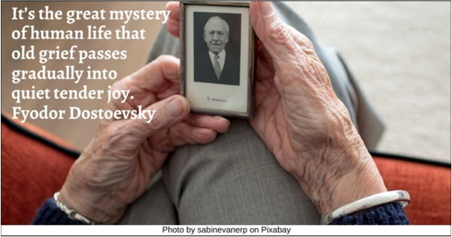



Piano HRJ
River HRJ
Rose HRJ
Shadow HRJ

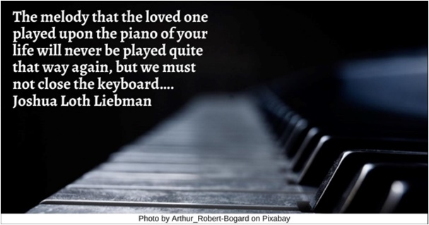

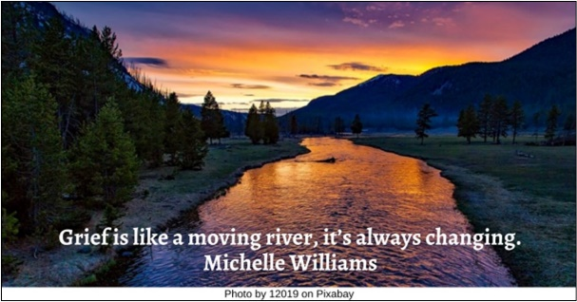





Sky HRJ
Sorrow HRJ
Tea HRJ
Tears HRJ





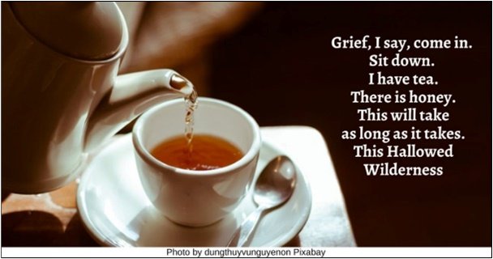



Waves on Beach HRJ
Weaving HRJ
Young Old HRJ

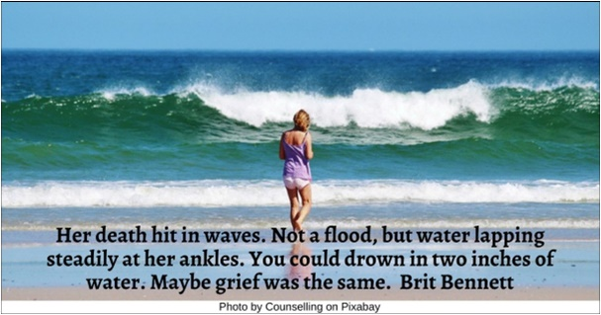

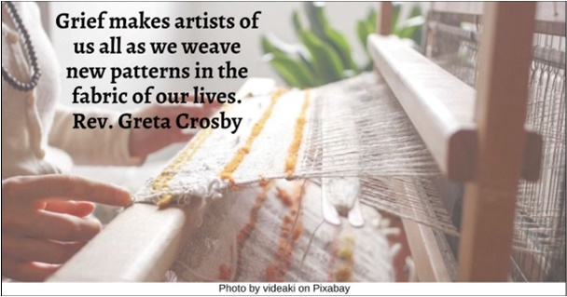



Text of Quotes

Avoiding Grief HRJ
If you're trying to avoid loss, there's no point in taking another breath, or letting your heart beat one more time. Leah Raeder

Candle HRJ
Grief does not expire like a candle or the beacon on a lighthouse. It simply changes temperature. Anthony Rapp

Clock HRJ
No matter how bad your heart is broken, the world doesn’t stop for your grief. Faraaz Kazi

Crying HRJ
For the most part, grief is not a problem to be solved, not a condition to be medicated, but a deep encounter with an essential experience of being human. Francis Weller

DNA Strand HRJ
I know that grief, like regret, settles into our DNA and remains forever a part of us. Kristin Hannah

Fertile Ground HRJ
Grief offers a wild alchemy that transmutes suffering into fertile ground. Francis Weller

Flowers in Vase HRJ
I don’t think of all the misery, but of all the beauty that remains. Anne Frank

Forest HRJ
I will welcome happiness for it enlarges my heart; yet I will endure sadness for it opens my soul. Og Mandino

Gravestone HRJ
Death ends a life, not a relationship. Robert Benchley

Grief HRJ
The only cure for grief is to grieve. Earl Grollman

Heart HRJ
We get no choice. If we love, we grieve. Thomas Lynch

Hourglass broken HRJ
They say time heals all wounds, but that presumes the source of the grief is finite. Cassandra Clare

Invitation HRJ
Love is an engraved invitation to grief. Sunshine O’Donnell

Kindness HRJ
All are going to lose everything they love in this world. Why would one want to be anything but kind to them in the meantime? Sam Harris

Maze HRJ
The only way to end grief was to go through it. Holly Black

Medicine HRJ
Grief is itself a medicine. William Cowper

Music HRJ
Music isn’t just a pleasure, a transient satisfaction. It’s a need, a deep hunger; and when the music is right, it’s joy. Love. A foretaste of heaven. A comfort in grief. Orson Scott Card

Ocean HRJ
Grief is like the ocean; it comes on waves ebbing and flowing. Sometimes the water is calm, and sometimes it is overwhelming. All we can do is learn to swim. Vicki Harrison

Old Woman HRJ
It’s the great mystery of human life that old grief passes gradually into quiet tender joy. Fyodor Dostoevsky
Photo by sabinevanerp on Pixabay

Photographer HRJ
Look at everything as though you were seeing it for the first time or the last time. Betty Smith

Piano HRJ
The melody that the loved one played upon the piano of your life will never be played quite that way again, but we must not close the keyboard…. Joshua Loth Liebman

River HRJ
Grief is like a moving river, it’s always changing. Michelle Williams

Rose HRJ
God gave us memory so that we might have roses in December. J.M. Barrie

Shadow HRJ
Our refusal to welcome the sorrows that come to us condemns us to a life shadowed by grief. Welcoming everything that comes to us is the challenge. Francis Weller

Sky HRJ
Her absence is like the sky, spread over everything. C.S. Lewis

Sorrow HRJ
Grief is not a problem to be solved, not a condition to be medicated, but a deep encounter with an essential experience of being human. Francis Weller

Tea HRJ
Grief, I say, come in. Sit down. I have tea. There is honey. This will take as long as it takes. This Hallowed Wilderness

Tears HRJ
There is a sacredness in tears.... They are the messengers of overwhelming grief, of deep contrition and of unspeakable love. Washington Irving

Waves on Beach HRJ
Her death hit in waves. Not a flood, but water lapping steadily at her ankles. You could drown in two inches of water. Maybe grief was the same. Brit Bennett

Weaving HRJ
Grief makes artists of us all as we weave new patterns in the fabric of our lives. Rev. Greta Crosby

Young Old HRJ
Youth offers the promise of happiness, but life offers the realities of grief. Nicholas Sparks

